**WEEK 7 - REACT (CONT.)**

**TASK - 9**

### src/Components/ListOfPlayers.js

importReactfrom'react';

functionListOfPlayers({ players }) {

return (

<div>

<h2>All Cricket Players</h2>

<ul>

{players.map((player, index) => (

<likey={index}>

{player.name} - Score: {player.score}

</li>

))}

</ul>

</div>

);

}

exportdefaultListOfPlayers;

### 📄 src/Components/IndianPlayers.js

importReactfrom'react';

functionIndianPlayers({ players }) {

const filtered = players.filter(player => player.score<70);

return (

<div>

<h2>Indian Players (Score &lt; 70)</h2>

<ul>

{filtered.map((player, index) => (

<likey={index}>

{player.name} - Score: {player.score}

</li>

))}

</ul>

</div>

);

}

exportdefaultIndianPlayers;

### 📄src/App.js

importReactfrom'react';importListOfPlayersfrom'./Components/ListOfPlayers';importIndianPlayersfrom'./Components/IndianPlayers';

functionApp() {

const T20Players = [

{ name: 'Virat Kohli', score: 85 },

{ name: 'Rohit Sharma', score: 95 },

{ name: 'Hardik Pandya', score: 45 }

];

constRanjiTrophyPlayers = [

{ name: 'Shubman Gill', score: 68 },

{ name: 'Ruturaj Gaikwad', score: 72 },

{ name: 'Sarfaraz Khan', score: 61 }

];

// 1. Merge arrays

const allPlayers = [...T20Players, ...RanjiTrophyPlayers];

// 2. Add more to make it 11 players

const extraPlayers = [

{ name: 'MS Dhoni', score: 70 },

{ name: 'R Ashwin', score: 30 },

{ name: 'Bumrah', score: 60 },

{ name: 'KL Rahul', score: 74 },

{ name: 'Ishan Kishan', score: 25 },

];

const completeTeam = [...allPlayers, ...extraPlayers];

// 3. Flag for conditional rendering

const showAll = true;

// 4. Destructuring example: odd vs even index players

const oddPlayers = completeTeam.filter((_, i) => i % 2 !== 0);

const evenPlayers = completeTeam.filter((_, i) => i % 2 === 0);

return (

<divstyle={{padding: '20px', fontFamily: 'Arial' }}>

<h1>🏏 Cricket Player App</h1>

<hr />

{showAll ? (

<ListOfPlayersplayers={completeTeam} />

) : (

<IndianPlayersplayers={completeTeam} />

)}

<hr />

<h2>Players at Even Positions</h2>

<ul>

{evenPlayers.map((player, i) => (

<likey={i}>{player.name}</li>

))}

</ul>

<h2>Players at Odd Positions</h2>

<ul>

{oddPlayers.map((player, i) => (

<likey={i}>{player.name}</li>

))}

</ul>

</div>

);

}

exportdefaultApp;

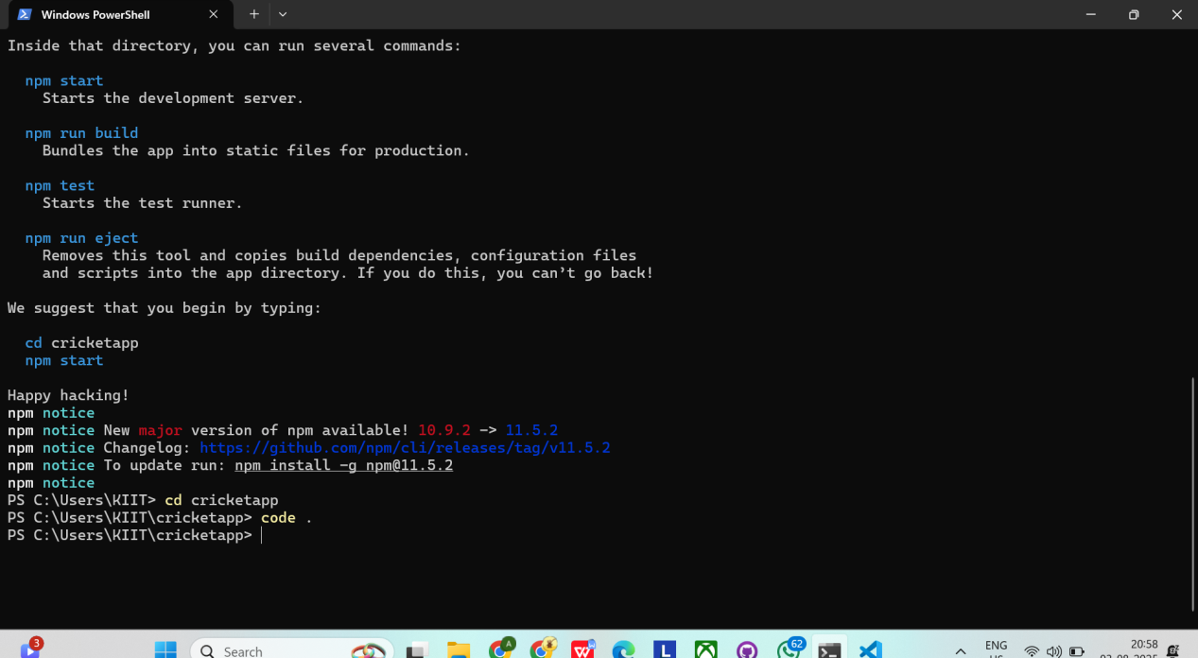

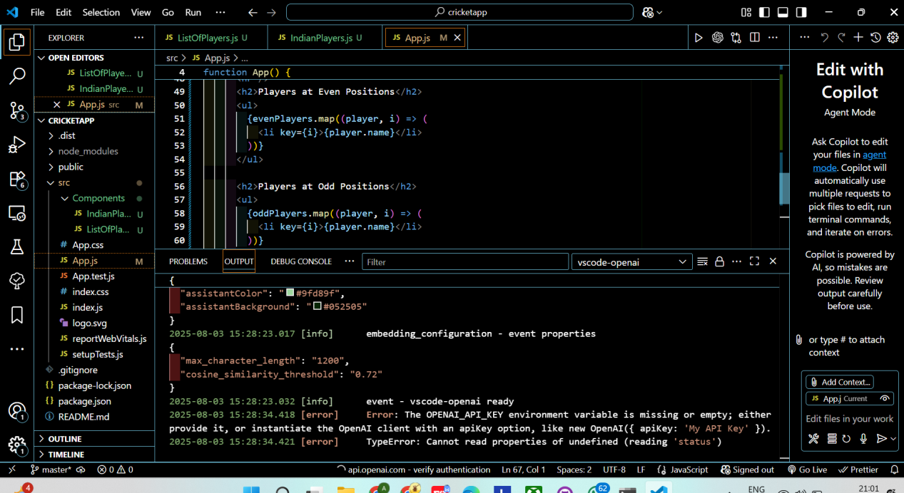

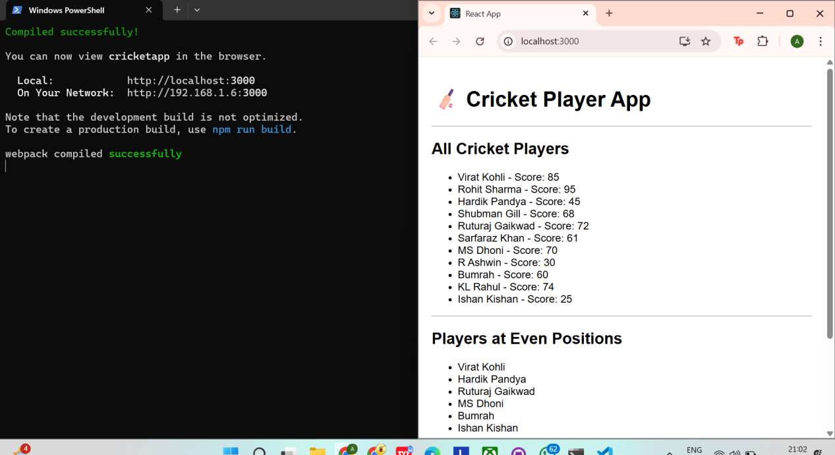

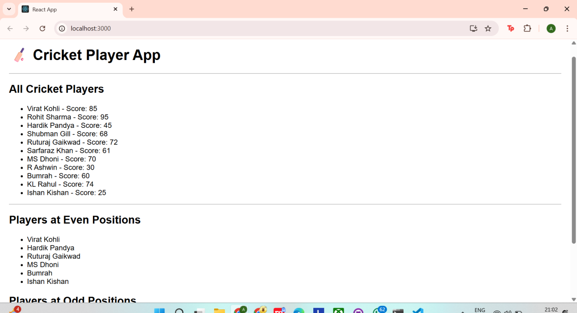

**TASK - 10**

### src/Components/OfficeList.js

importReactfrom'react';

functionOfficeList() {

const officeSpaces = [

{ name: "WeWork", rent: 85000, address: "MG Road, Bangalore" },

{ name: "Innov8", rent: 55000, address: "Connaught Place, Delhi" },

{ name: "91Springboard", rent: 72000, address: "Baner, Pune" },

{ name: "SmartWorks", rent: 40000, address: "Gachibowli, Hyderabad" },

];

return (

<divstyle={{fontFamily:"Arial", padding:"20px" }}>

<h1>🏢 <strong>Office Space Rental App</strong></h1>

<ulstyle={{listStyle:"none", padding:0 }}>

{officeSpaces.map((office, index) => (

<likey={index}style={{marginBottom:"20px" }}>

<h3>{office.name}</h3>

<p><strong>Address:</strong> {office.address}</p>

<p>

<strong>Rent:</strong>{""}

<span

style={{

color:office.rent>= 60000 ? "green" : "red",

fontWeight: "bold"

}}

>

₹{office.rent}

</span>

</p>

<hr />

</li>

))}

</ul>

</div>

);

}

exportdefaultOfficeList;

### src/App.js

import'./App.css';importOfficeListfrom'./Components/OfficeList';

functionApp() {

return (

<divclassName="App">

<OfficeList />

</div>

);

}

exportdefaultApp;

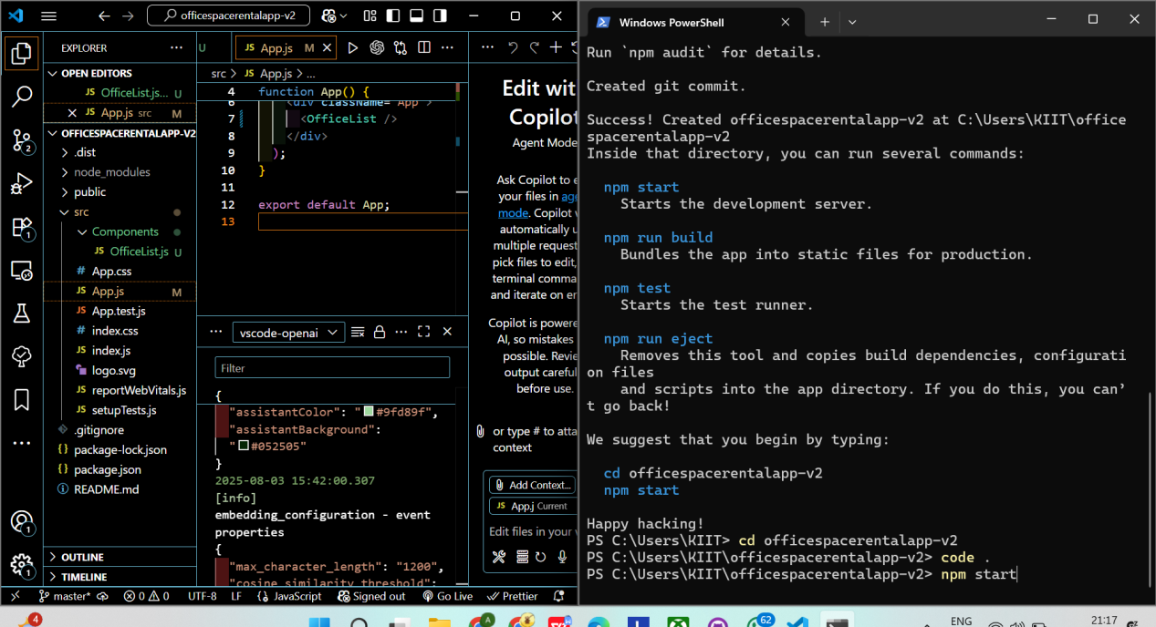

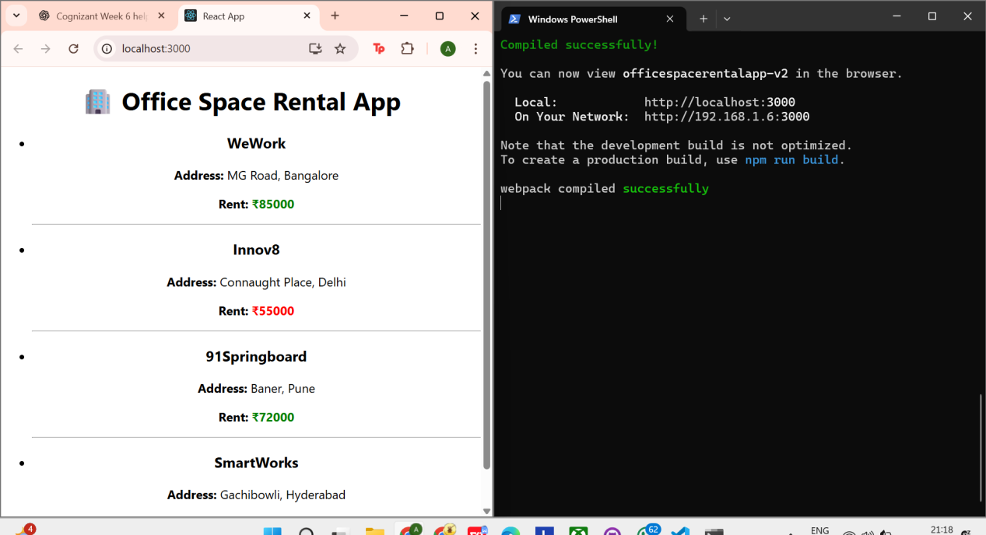

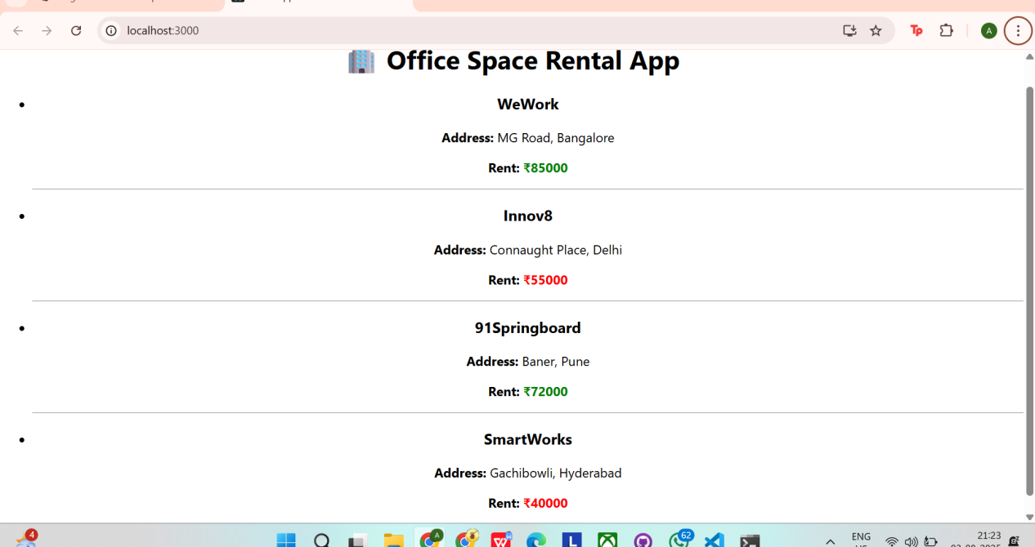

**TASK - 11**

**src/Components/StudentForm.js**

import React, { useState } from 'react';

function StudentForm() {

const [name, setName] = useState('');

const [school, setSchool] = useState('');

const [totalMarks, setTotalMarks] = useState('');

const [goalMarks, setGoalMarks] = useState('');

const [percentage, setPercentage] = useState(null);

const calculatePercentage = () => {

if (totalMarks && goalMarks && !isNaN(totalMarks) && !isNaN(goalMarks)) {

const result = (parseFloat(totalMarks) / parseFloat(goalMarks)) * 100;

setPercentage(result.toFixed(2));

} else {

setPercentage('Invalid Input');

}

};

return (

<div style={{ fontFamily: 'Arial', padding: '20px', textAlign: 'center' }}>

<h1>📘 Student Score Calculator</h1>

<input

type="text"

placeholder="Enter Name"

value={name}

onChange={(e) => setName(e.target.value)}

style={{ margin: '5px' }}

/>

<br />

<input

type="text"

placeholder="Enter School"

value={school}

onChange={(e) => setSchool(e.target.value)}

style={{ margin: '5px' }}

/>

<br />

<input

type="number"

placeholder="Enter Total Marks"

value={totalMarks}

onChange={(e) => setTotalMarks(e.target.value)}

style={{ margin: '5px' }}

/>

<br />

<input

type="number"

placeholder="Enter Goal Marks"

value={goalMarks}

onChange={(e) => setGoalMarks(e.target.value)}

style={{ margin: '5px' }}

/>

<br />

<button onClick={calculatePercentage} style={{ margin: '10px' }}>

Calculate Percentage

</button>

{percentage && (

<div>

<p><strong>Name:</strong> {name}</p>

<p><strong>School:</strong> {school}</p>

<p><strong>Percentage:</strong> {percentage}%</p>

</div>

)}

</div>

);

}

export default StudentForm;

**src/App.js**

import './App.css';

import StudentForm from './Components/StudentForm';

function App() {

return (

<div className="App">

<StudentForm />

</div>

);

}

export default App;

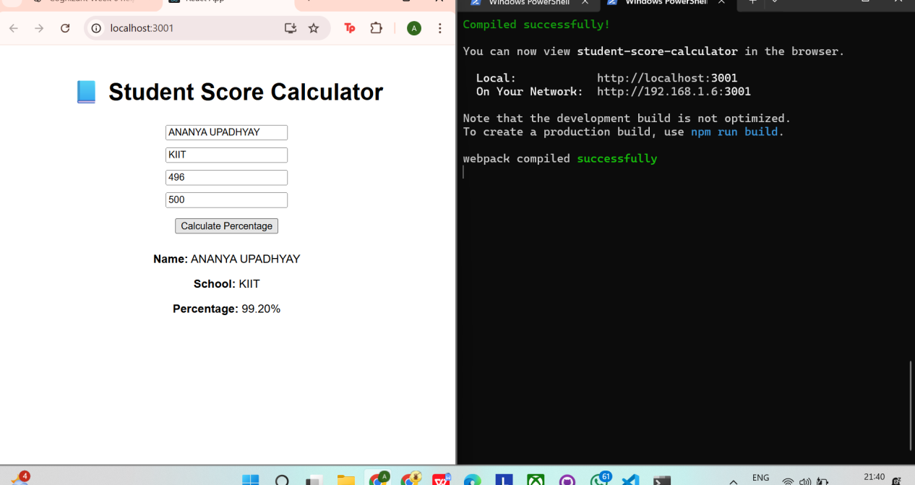

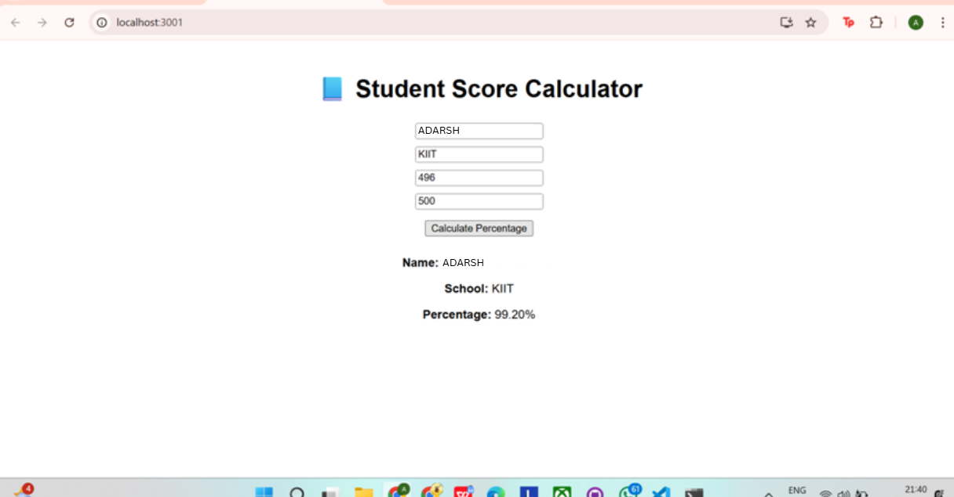

**TASK - 12**

### App.js

importReact, { useState } from'react';importProductListfrom'./components/ProductList';importCartfrom'./components/Cart';import'./App.css';

functionApp() {

const [cartItems, setCartItems] = useState([]);

consthandleAddToCart = (product) => {

setCartItems([...cartItems, product]);

};

return (

<divclassName="App">

<h1>🛒 React Shopping Cart</h1>

<h3>Total Items in Cart: {cartItems.length}</h3>

<ProductListonAddToCart={handleAddToCart} />

<CartcartItems={cartItems} />

</div>

);

}

exportdefaultApp;

### ProductList.js

importReactfrom'react';

const products = [

{ id: 1, name: 'Headphones', price: 1999 },

{ id: 2, name: 'Bluetooth Speaker', price: 2999 },

{ id: 3, name: 'Wireless Mouse', price: 799 },

];

functionProductList({ onAddToCart }) {

return (

<div>

<h2>🛍️ Available Products</h2>

<ul>

{products.map(product => (

<likey={product.id}style={{marginBottom: '10px' }}>

<strong>{product.name}</strong> - ₹{product.price}

<button

style={{marginLeft: '10px' }}

onClick={() => onAddToCart(product)}

>

Add to Cart

</button>

</li>

))}

</ul>

</div>

);

}

exportdefaultProductList;

### components/Cart.js

importReactfrom'react';

functionCart({ cartItems }) {

return (

<div>

<h2>🧾 Items in Cart</h2>

{cartItems.length === 0 ? (

<p>No items yet 😶</p>

) : (

<ul>

{cartItems.map((item, index) => (

<likey={index}>

{item.name} - ₹{item.price}

</li>

))}

</ul>

)}

</div>

);

}

exportdefaultCart;

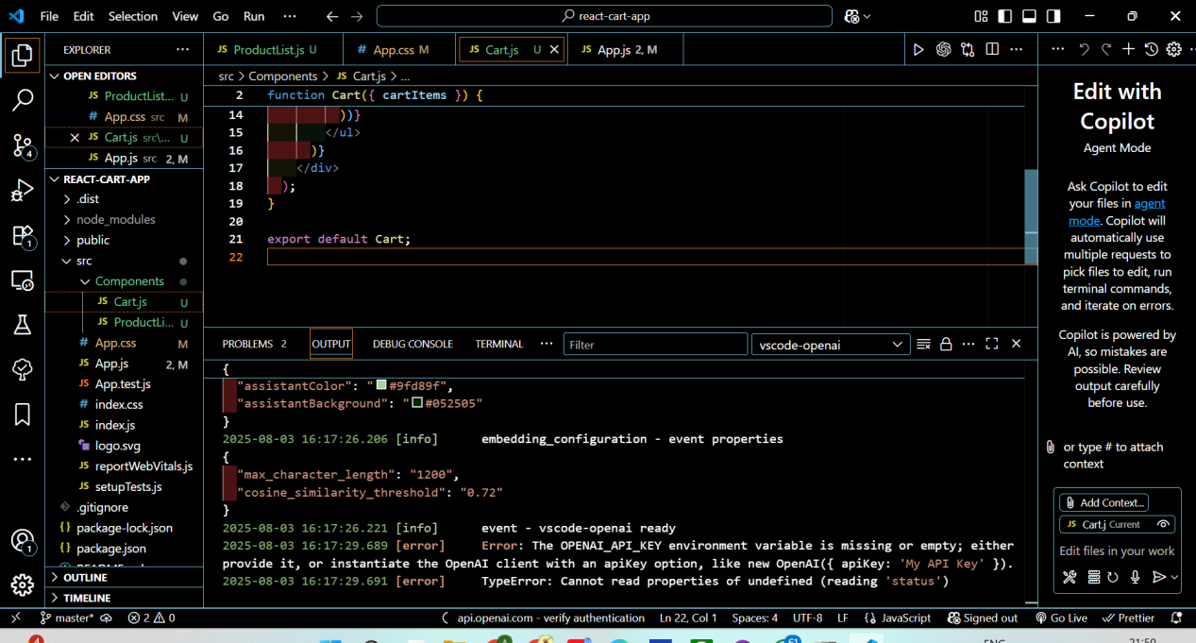

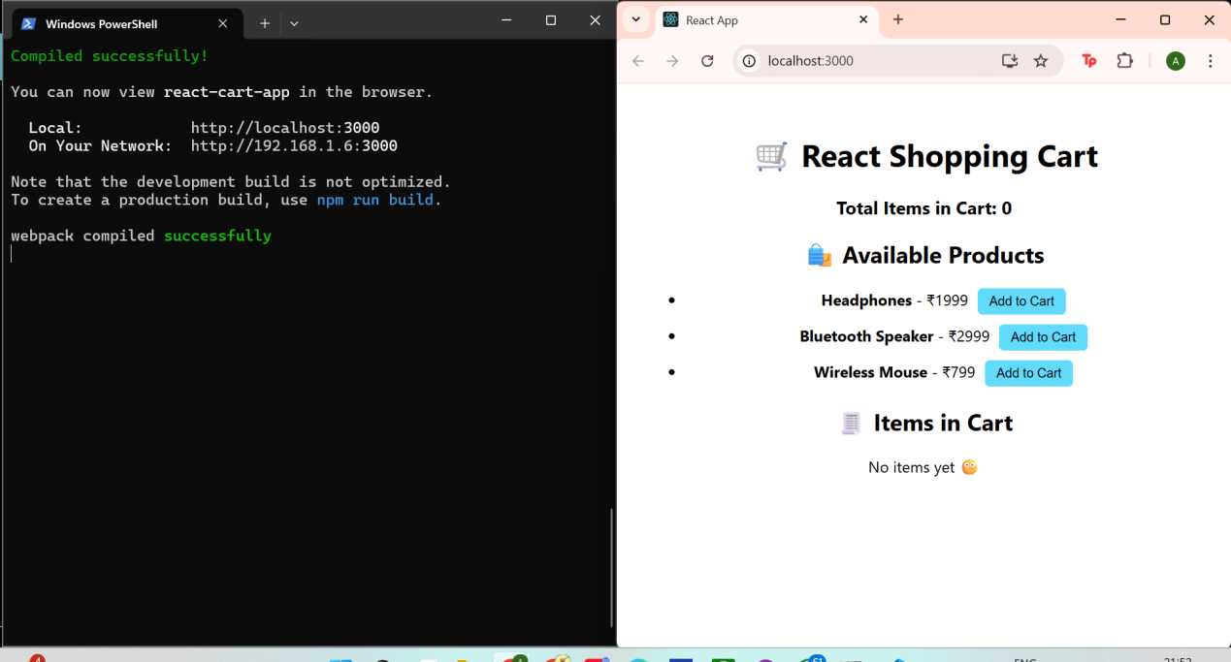

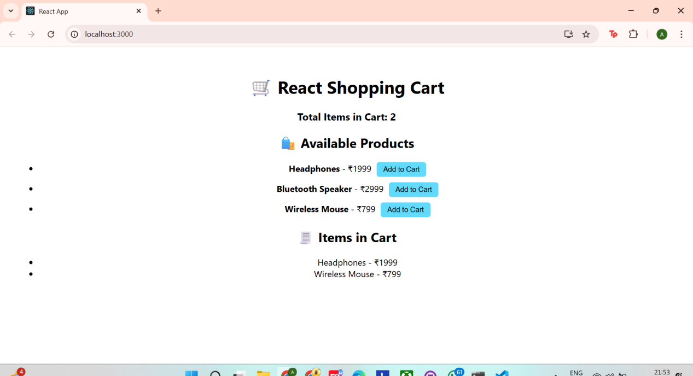

**TASK - 13**

### App.js

import'./App.css';importStudentProfileFormfrom'./components/StudentProfileForm';

functionApp() {

return (

<divclassName="App">

<StudentProfileForm />

</div>

);

}

exportdefaultApp;

### StudentProfileForm.js

jsx

Copy code

importReact, { useState } from'react';

functionStudentProfileForm() {

const [name, setName] = useState('');

const [age, setAge] = useState('');

const [grade, setGrade] = useState('');

const [city, setCity] = useState('');

const [submitted, setSubmitted] = useState(false);

consthandleSubmit = (e) => {

e.preventDefault();

if (name && age && grade && city) {

setSubmitted(true);

} else {

alert('Please fill in all fields');

}

};

return (

<divstyle={{textAlign: 'center', padding: '20px', fontFamily: 'Arial' }}>

<h1>🎓 Student Profile App</h1>

<formonSubmit={handleSubmit}>

<input

type="text"

placeholder="Enter Name"

value={name}

onChange={(e) => setName(e.target.value)}

style={{ margin: '5px' }}

/>

<br />

<input

type="number"

placeholder="Enter Age"

value={age}

onChange={(e) => setAge(e.target.value)}

style={{ margin: '5px' }}

/>

<br />

<input

type="text"

placeholder="Enter Grade"

value={grade}

onChange={(e) => setGrade(e.target.value)}

style={{ margin: '5px' }}

/>

<br />

<input

type="text"

placeholder="Enter City"

value={city}

onChange={(e) => setCity(e.target.value)}

style={{ margin: '5px' }}

/>

<br />

<buttontype="submit"style={{margin: '10px' }}>Submit</button>

</form>

{submitted && (

<divstyle={{marginTop: '20px' }}>

<h3>📋 Student Profile:</h3>

<p><strong>Name:</strong> {name}</p>

<p><strong>Age:</strong> {age}</p>

<p><strong>Grade:</strong> {grade}</p>

<p><strong>City:</strong> {city}</p>

</div>

)}

</div>

);

}

exportdefaultStudentProfileForm;

